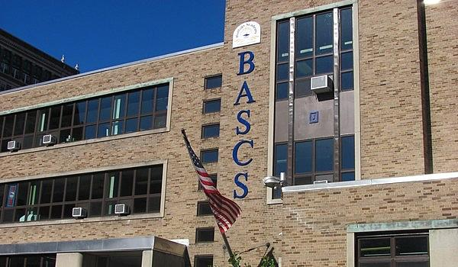

MINIMUM CAPACITY :-

The Minumum intake capacity

of students is between 150-350

children

LIBRARY :-

The Libarary is Available.

CANTEEN:-

The Canteen Facility is Available.

BOARDING :-

No availablility of boarding.

SPORTS :-

There are different categories

sports available.

Girls Volleyball

Boys Volleyball

Football

|  |  |  |  |
| --- | --- | --- | --- |
| BUFFALO ACADEMY OF SCIENCE CHARTER SCHOOL  BUFFALO - SCHOOL | |  |  |
| School Detail :- The Buffalo Academy of Science Charter School (BuffSci) is a tuition-free, college preparatory charter school for grades Kindergarten through 12th. We are dedicated to providing quality education to a diverse body of students of Greater Buffalo in Western New York.  Buffalo Academy Of Science Charter School placed in the top 10% of all schools in New York for overall test scores (math proficiency is top 5%, and reading proficiency is top 20%) for the 2018-19 school year.  Minority enrollment is 86% of the student body (majority Black), which is higher than the New York state average of 57% (majority Hispanic and Black).  The percentage of students achieving proficiency in math is ≥95% (which is higher than the New York state average of 54%) for the 2018-19 school year. The percentage of students achieving proficiency in reading/language arts is 90-94% (which is higher than the New York state average of 52%) for the 2018-19 school year. | |  |  |
|  |
|